General Trapezoid

Definition
# Source: AI Source: Provided by: [Data Path: Persons Table -> ID Column: 1, Name_En Column: Motasem Essam] -> From: [ChatGPT] on [7/25/2026]
A general trapezoid is a quadrilateral with one pair of parallel opposite sides and without the additional special properties that characterize an isosceles trapezoid or a right trapezoid.
For trapezoid $ABCD$, if
$$AB∥CD$$
then $AB$ and $CD$are the bases.
The remaining sides $AD$ and $BC$are the legs.
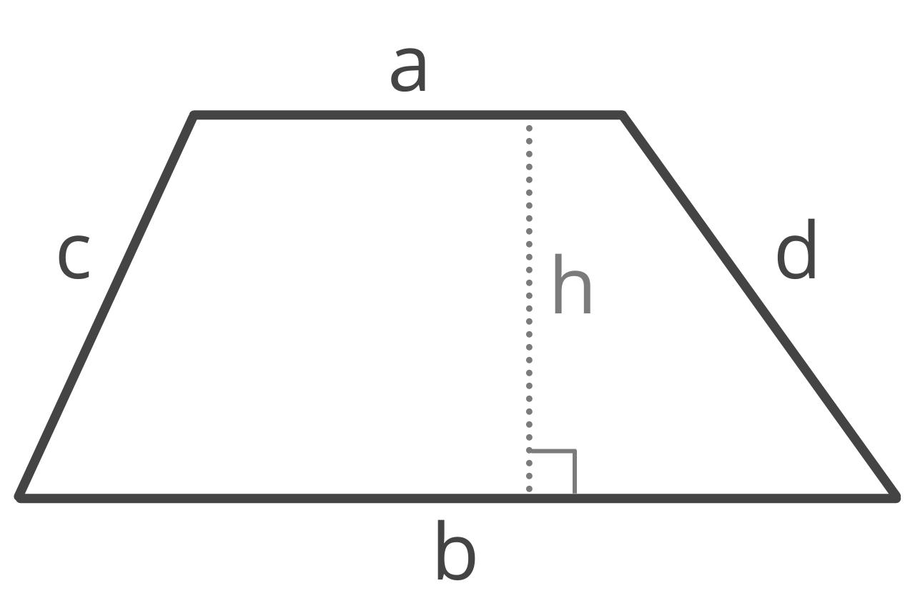
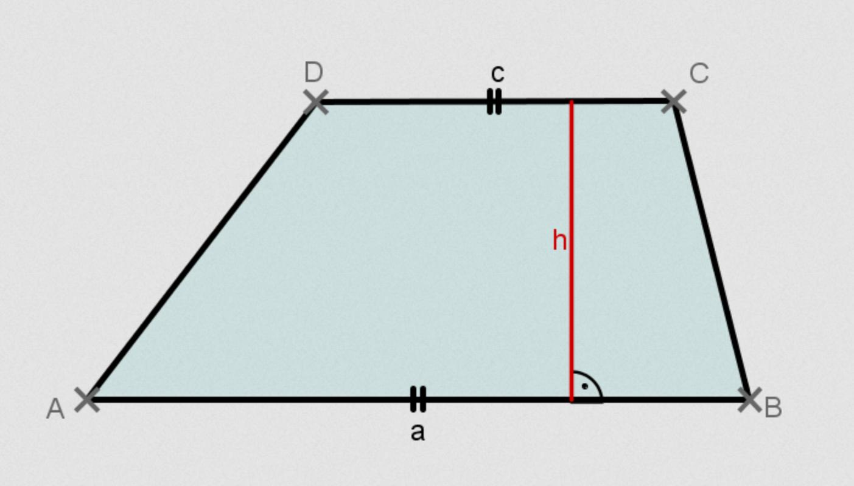
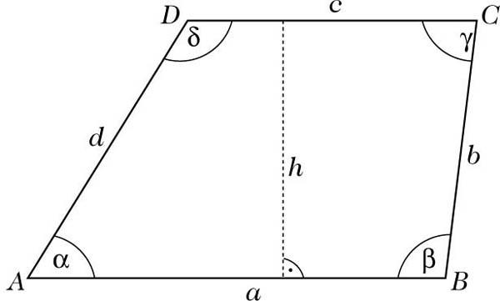
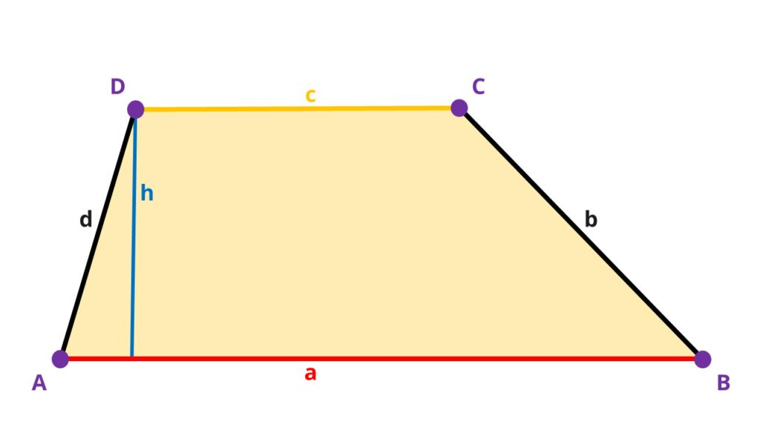
Terminology note: Some textbooks define "trapezoid" as having exactly one pair of parallel sides, while others use at least one pair. In the first convention, a general trapezoid specifically has exactly one pair of parallel sides.

Purpose
# Source: AI Source: Provided by: [Data Path: Persons Table -> ID Column: 1, Name_En Column: Motasem Essam] -> From: [ChatGPT] on [7/25/2026]
The general trapezoid is used to:
- Study the basic properties of trapezoids.
- Understand relationships between parallel bases and legs.
- Calculate area and perimeter.
- Analyze angles created by parallel lines.
- Provide the basic form from which special trapezoids are distinguished.

Fundamental Elements
# Source: AI Source: Provided by: [Data Path: Persons Table -> ID Column: 1, Name_En Column: Motasem Essam] -> From: [ChatGPT] on [7/25/2026]
Consider general trapezoid $ABCD$, where
$$AB∥CD$$
1. Bases
The parallel sides are the bases:
$$\overset{‾}{AB}, \overset{‾}{CD}$$
Usually, one base is called the upper base and the other the lower base.
2. Legs
The non-parallel sides are the legs:
$$\overset{‾}{AD}, \overset{‾}{BC}$$
In a general trapezoid, the legs do not have to be equal.
3. Vertices
The four vertices are
$$A, B, C, D$$
4. Interior Angles
The four interior angles are
$$∠A, ∠B, ∠C, ∠D$$
5. Height
The height $h$is the perpendicular distance between the two parallel bases.
$$h⊥AB$$
and
$$h⊥CD$$
6. Diagonals
The two diagonals are
$$\overset{‾}{AC}$$
and
$$\overset{‾}{BD}$$
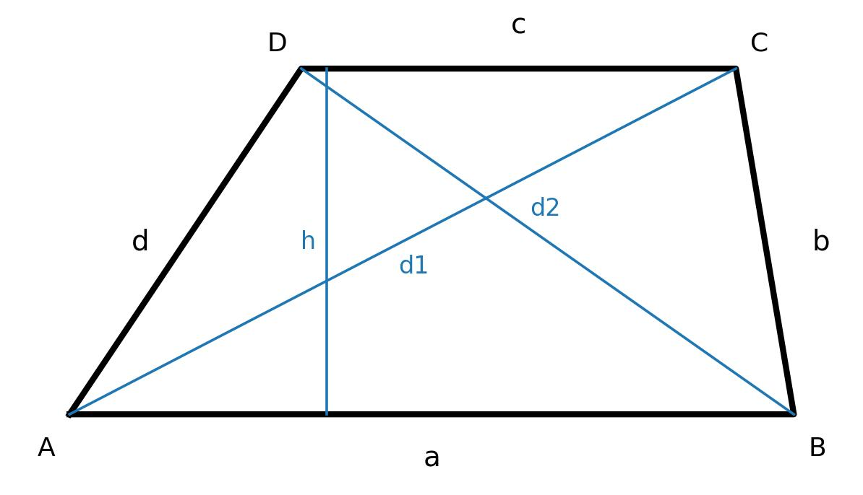
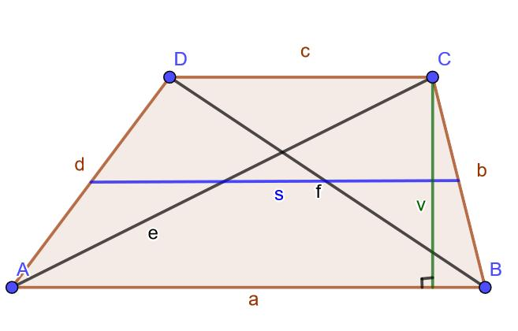
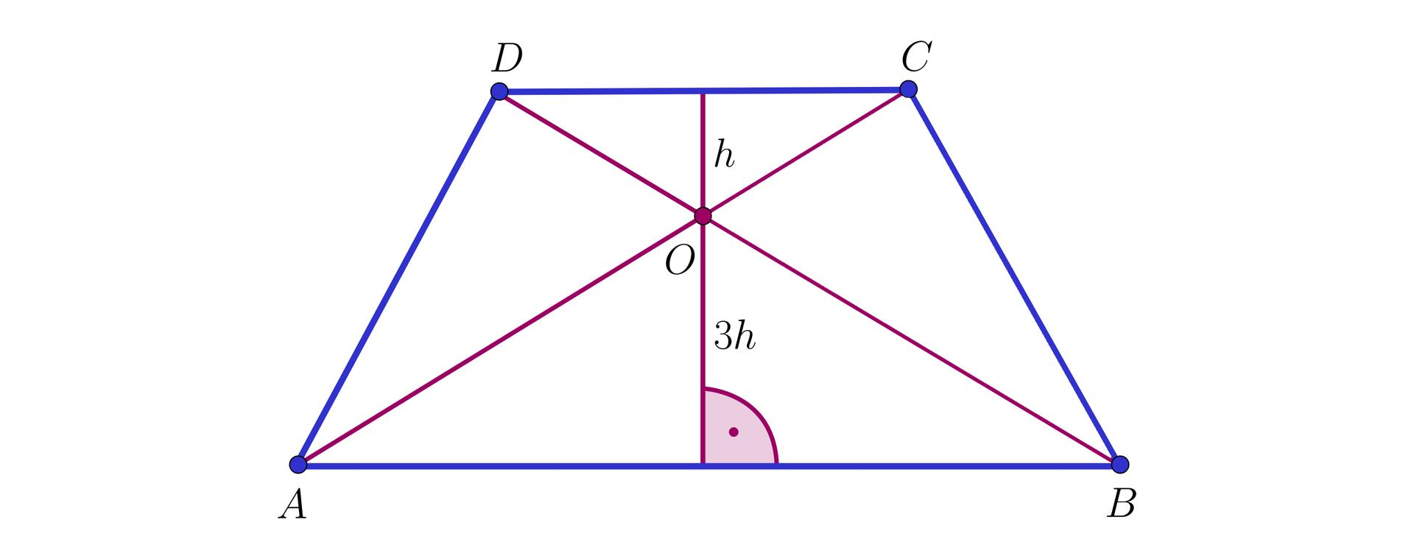
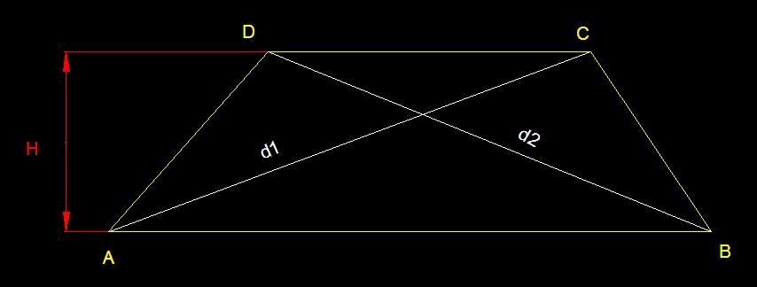
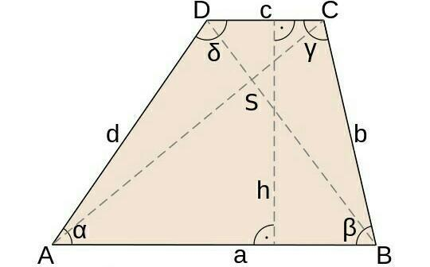

Main Properties
# Source: AI Source: Provided by: [Data Path: Persons Table -> ID Column: 1, Name_En Column: Motasem Essam] -> From: [ChatGPT] on [7/25/2026]
A general trapezoid has the following properties:
Parallel Bases
$$AB∥CD$$
This is its defining geometric feature.
Interior Angle Sum
Because it is a quadrilateral,
$$∠A+∠B+∠C+∠D={360}^{∘}$$
Consecutive Angles Along Each Leg
Since the bases are parallel,
$$∠A+∠D={180}^{∘}$$
and
$$∠B+∠C={180}^{∘}$$
Unequal Legs
Unlike an isosceles trapezoid, a general trapezoid does not require
$$AD=BC$$
Unequal Diagonals
The diagonals do not generally have equal lengths:
$$AC≠BD$$
No Required Symmetry
A general trapezoid does not necessarily have:
- line symmetry
- rotational symmetry

Mathematical Representation
# Source: AI Source: Provided by: [Data Path: Persons Table -> ID Column: 1, Name_En Column: Motasem Essam] -> From: [ChatGPT] on [7/25/2026]
Let:
- $a$= length of the first base
- $b$= length of the second base
- $c$= first leg
- $d$= second leg
- $h$= height

Area
# Source: AI Source: Provided by: [Data Path: Persons Table -> ID Column: 1, Name_En Column: Motasem Essam] -> From: [ChatGPT] on [7/25/2026]
$$A=\frac{\left(a+b\right)h}{2}$$
or
$$\boxed{A=\frac{\left(a+b\right)h}{2}}$$

Perimeter
# Source: AI Source: Provided by: [Data Path: Persons Table -> ID Column: 1, Name_En Column: Motasem Essam] -> From: [ChatGPT] on [7/25/2026]
$$P=a+b+c+d$$
Therefore,
$$\boxed{P=a+b+c+d}$$

Midsegment
# Source: AI Source: Provided by: [Data Path: Persons Table -> ID Column: 1, Name_En Column: Motasem Essam] -> From: [ChatGPT] on [7/25/2026]
A general trapezoid also has a midsegment, sometimes called the median or midline.
It connects the midpoints of the two legs and is parallel to the bases.
Its length is
$$m=\frac{a+b}{2}$$
Therefore, the area can also be written as
$$A=mh$$
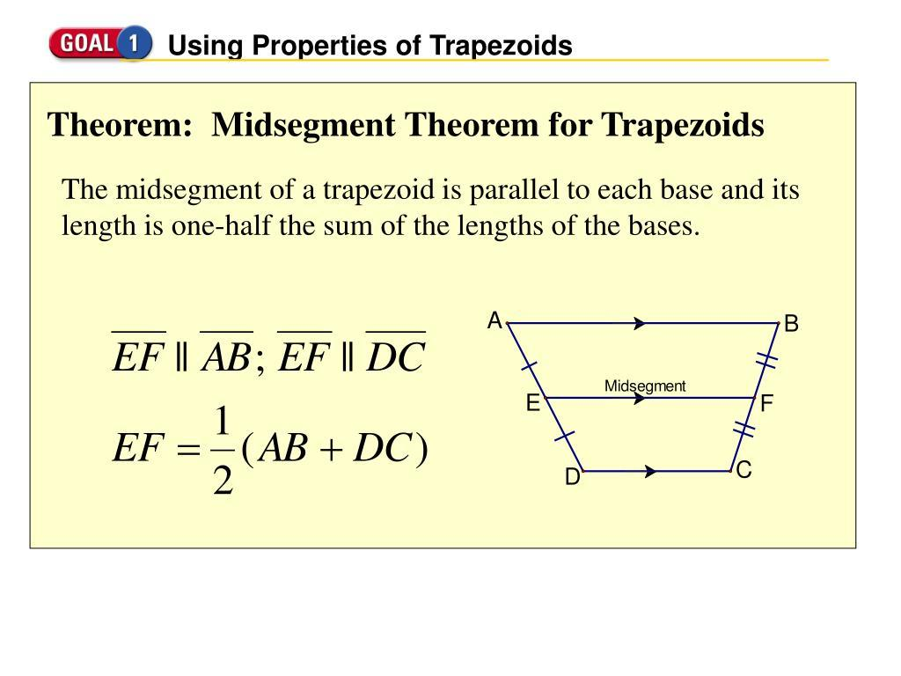
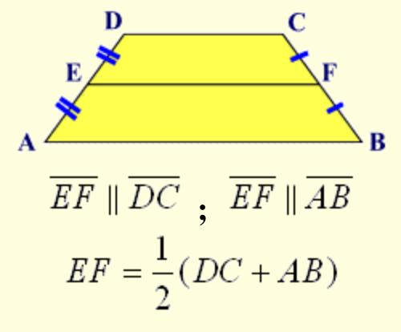
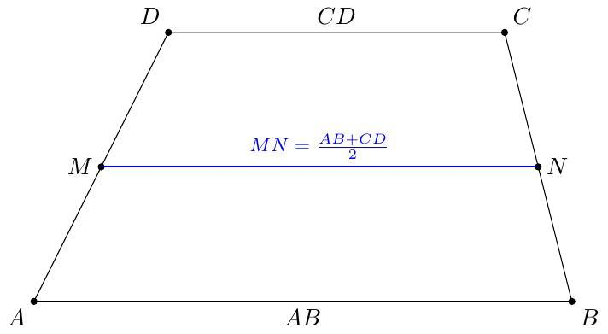
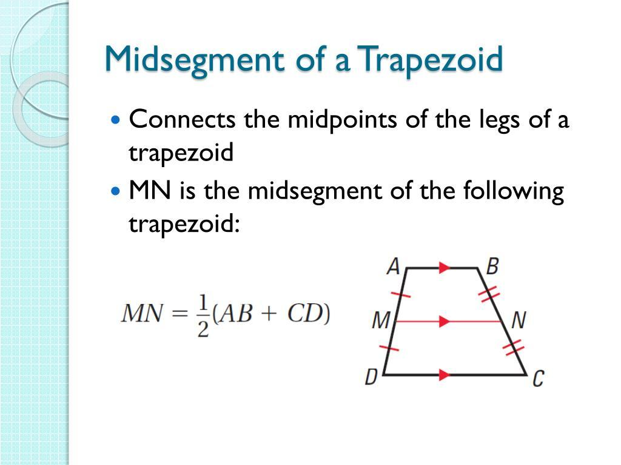

Example 1 — Area
# Source: AI Source: Provided by: [Data Path: Persons Table -> ID Column: 1, Name_En Column: Motasem Essam] -> From: [ChatGPT] on [7/25/2026]
A general trapezoid has bases
$$a=8\text{ cm}$$
and
$$b=14\text{ cm}$$
with height
$$h=5\text{ cm}$$
Then
$$A=\frac{\left(a+b\right)h}{2} \\ A=\frac{\left(8+14\right)\left(5\right)}{2} \\ A=\frac{22×5}{2} \\ \boxed{A=55{\text{ cm}}^{2}}$$

Example 2 — Perimeter
# Source: AI Source: Provided by: [Data Path: Persons Table -> ID Column: 1, Name_En Column: Motasem Essam] -> From: [ChatGPT] on [7/25/2026]
Suppose a general trapezoid has side lengths
$$8\text{ cm}, 14\text{ cm}, 6\text{ cm}, 7\text{ cm}$$
Then
$$P=8+14+6+7 \\ \boxed{P=35\text{ cm}}$$

Example 3 — Angles
# Source: AI Source: Provided by: [Data Path: Persons Table -> ID Column: 1, Name_En Column: Motasem Essam] -> From: [ChatGPT] on [7/25/2026]
Suppose
$$∠A={65}^{∘}$$
Because $AB∥CD$, angles $A$and $D$are supplementary:
$$∠A+∠D={180}^{∘}$$
Therefore,
$${65}^{∘}+∠D={180}^{∘} \\ \boxed{∠D={115}^{∘}}$$

General Trapezoid vs. Special Trapezoids
# Source: AI Source: Provided by: [Data Path: Persons Table -> ID Column: 1, Name_En Column: Motasem Essam] -> From: [ChatGPT] on [7/25/2026]
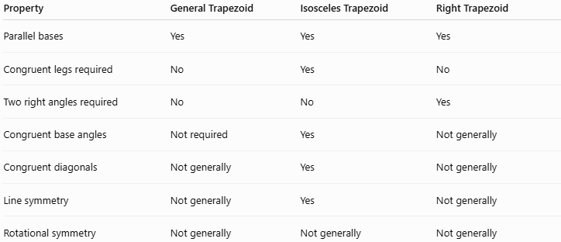
Property | General Trapezoid | Isosceles Trapezoid | Right Trapezoid
Parallel bases | Yes | Yes | Yes
Congruent legs required | No | Yes | No
Two right angles required | No | No | Yes
Congruent base angles | Not required | Yes | Not generally
Congruent diagonals | Not generally | Yes | Not generally
Line symmetry | Not generally | Yes | Not generally
Rotational symmetry | Not generally | Not generally | Not generally

What Makes It "General"?
# Source: AI Source: Provided by: [Data Path: Persons Table -> ID Column: 1, Name_En Column: Motasem Essam] -> From: [ChatGPT] on [7/25/2026]
A trapezoid is called general when it does not have the special restrictions of other trapezoids.
For example:
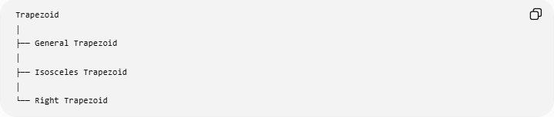
Trapezoid
│
├── General Trapezoid
│
├── Isosceles Trapezoid
│
└── Right Trapezoid
A general trapezoid can have:
- unequal bases
- unequal legs
- unequal diagonals
- four different angles
- no line of symmetry
But it must still satisfy its defining condition:
$$\boxed{\text{One pair of opposite sides is parallel}}$$

Real-World Applications
# Source: AI Source: Provided by: [Data Path: Persons Table -> ID Column: 1, Name_En Column: Motasem Essam] -> From: [ChatGPT] on [7/25/2026]
General trapezoids can appear in:
- Architectural structures
- Engineering components
- Bridge designs
- Land plots
- Furniture designs
- Packaging
- Mechanical parts
- Decorative patterns
- Construction layouts

Advantages
# Source: AI Source: Provided by: [Data Path: Persons Table -> ID Column: 1, Name_En Column: Motasem Essam] -> From: [ChatGPT] on [7/25/2026]
- Simple and flexible geometric structure.
- Useful for calculating irregular areas.
- Models many real-world shapes.
- Provides the basic form for studying special trapezoids.
- Has useful relationships resulting from its parallel bases.

Limitations
# Source: AI Source: Provided by: [Data Path: Persons Table -> ID Column: 1, Name_En Column: Motasem Essam] -> From: [ChatGPT] on [7/25/2026]
A general trapezoid does not generally have:
- equal legs
- equal diagonals
- right angles
- symmetry
- perpendicular diagonals
- diagonals that bisect each other
These properties belong to particular special quadrilaterals or special trapezoids.

Key Points
# Source: AI Source: Provided by: [Data Path: Persons Table -> ID Column: 1, Name_En Column: Motasem Essam] -> From: [ChatGPT] on [7/25/2026]
- A general trapezoid is a basic form of trapezoid.
- It has one pair of parallel opposite sides under the exclusive convention.
- The parallel sides are the bases.
- The other two sides are the legs.
- Its height is perpendicular to the bases.
- Its interior angles sum to
$$\boxed{{360}^{∘}}$$
- Consecutive angles along each leg are supplementary.
- Area:
$$\boxed{A=\frac{\left(a+b\right)h}{2}}$$
- Perimeter:
$$\boxed{P=a+b+c+d}$$
- Midsegment:
$$\boxed{m=\frac{a+b}{2}}$$
- It does not generally have equal legs, equal diagonals, or symmetry.

Conclusion
# Source: AI Source: Provided by: [Data Path: Persons Table -> ID Column: 1, Name_En Column: Motasem Essam] -> From: [ChatGPT] on [7/25/2026]
A General Trapezoid is the fundamental, non-special form of a trapezoid. Its defining characteristic is the presence of one pair of parallel sides, called the bases. Unlike isosceles and right trapezoids, it has no additional requirements concerning equal legs, right angles, symmetry, or diagonal lengths. Its most important formulas are its area, perimeter, and midsegment formulas.
Would you like a labeled diagram or a few practice problems about general trapezoids?

